Bahria University,

Karachi Campus



COURSE: CEL-221 Computer Architecture And Organization

TERM: FALL 2020, CLASS: BSE- 3 (A)

Submitted By:

_______________________________________________

(ADIL WAHEED) (65190)

Submitted To:

Engr. Muhammed Rehan Baig

Signed Remarks: Score:

INDEX

|  |  |  |  |  |
| --- | --- | --- | --- | --- |
| SNO | DATE | LAB NO | LAB OBJECTIVE | SIGN |
| 1 | **19 October 2020** | 1 | **INTRODUCTION TO VVM** |  |
| 2 | **19 October 2020** | 2 | **Introduction to VVM Programming** |  |
| 3 | **24 October 2020** | 3 | **VVM Programming** |  |
| 4 | **24 October 2020** | 4 | **Introduction to MIPS Assembly language** |  |
| 5 | **30 October 2020** | 5 | **MIPS ASSEMBLY LANGUAGE ARITHMETIC OPERATIONS** |  |
| 6 | **30 October 2020** | 6 | **MIPS ASSEMBLY LANGUAGE USING ADDU INSTRUCTION** |  |
| 7 | **8 November 2020** | 7 | **Arithmetic Instructions in MIPS** |  |
| 8 | **14 November 2020** | 8 | **MULTIPLICATION AND DIVISION INSTRUCTIONS IN MIPS** |  |
| 9 | **27 December 2020** | 9 | **BIT MANIPULATION INSTRUCTIONS IN MIPS** |  |
| 10 | **27 December 2020** | 10 | **IF THEN ELSE; CONTROL STRUCTURE IN MIPS** |  |
| 11 | **27 December 2020** | 11 | **FOR LOOP; CONTROL STRUCTURE IN MIPS** |  |
| 12 | **27 December 2020** | 12 | **SWITCH; Control Structure In MIPS** |  |
|  |  |  |  |  |
| SNO | DATE | LAB NO | LAB OBJECTIVE | SIGN |
|  |  |  |  |  |
|  |  |  |  |  |
|  |  |  |  |  |
|  |  |  |  |  |
|  |  |  |  |  |
|  |  |  |  |  |
|  |  |  |  |  |
|  |  |  |  |  |
|  |  |  |  |  |
|  |  |  |  |  |
|  |  |  |  |  |
|  |  |  |  |  |

Bahria University,

Karachi Campus



LAB EXPERIMENT NO.

___12____

LIST OF TASKS

|  |  |
| --- | --- |
| TASK NO | OBJECTIVE |
| 1 | **Write a program in MIPS assembly language by which you can show a**  **total of 10 cases from case0 to case9.** |
|  |  |
|  |  |
|  |  |
|  |  |

Submitted On:

____________

(Date: 27/12/20)

**TASK NO 1:** **Write a program in MIPS assembly language by which you can show a**

**total of 10 cases from case0 to case9.**

**SOLUTION:**

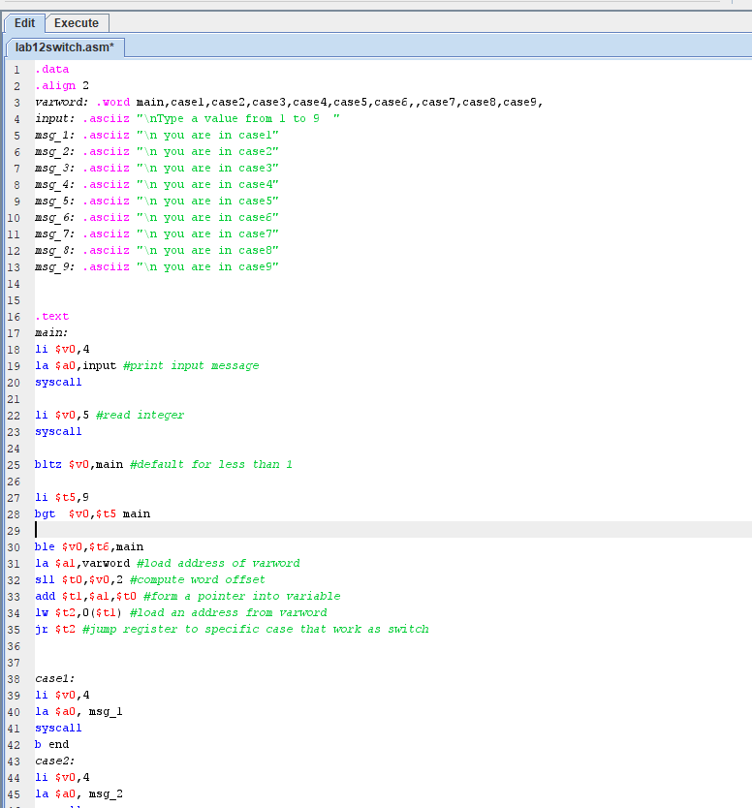

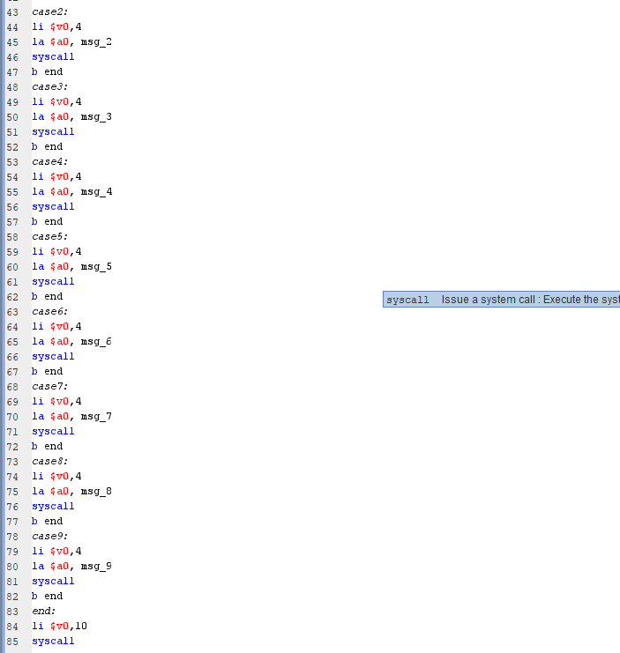

**OUTPUT:**

